UNLOCKING INSIGHTS INTO THE GLOBAL AIR TRANSPORTATION NETWORK WITH TABLEAU

INTRODUCTION:

Airport Information: This dataset provides details about airports, including their names, locations (cities and countries), and various codes such as IATA and ICAO codes. It also includes geographical coordinates (longitudes and latitudes) and altitudes. Furthermore, it contains information about time zones and saving time data for these airports.

Airline Information: The dataset covers extensive information about airlines, including their unique IDs, name aliases, IATA and ICAO codes, callsigns, country of origin, and their active or inactive status. This information allows for comprehensive insight into the global airline industry.

Route Details: It provides detailed information about routes, including the source and destination airports. Additionally, it includes information about codeshare agreements and stakeholders involved in these routes, if any. The dataset also specifies whether any stops are required during a journey and the type of aircraft used for each specific route.

PURPOSE:

It explains the contents and scope of the dataset, which includes information about airports, airlines, routes, time zones, and various other details related to global air transportation networks. This paragraph aims to convey the dataset's comprehensive nature, its origins, and the value it offers in understanding and analyzing the complex world of air travel.

EMPATHY MAP

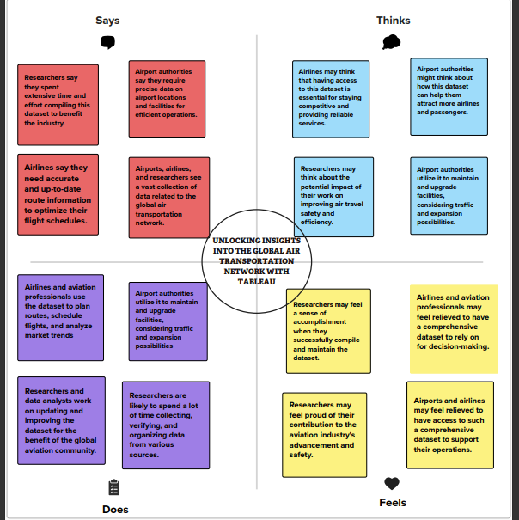

BRAIN STORM MAP

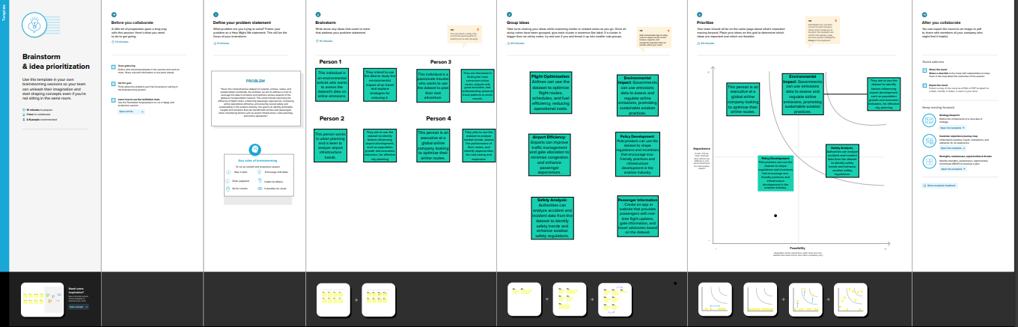

**RESULT:**

Environmental Impact**: Analyzing the dataset's information on airport altitudes and route distances can contribute to a deeper understanding of aviation's environmental impact. This insight can be used to explore strategies for reducing carbon emissions and improving eco-friendliness.**

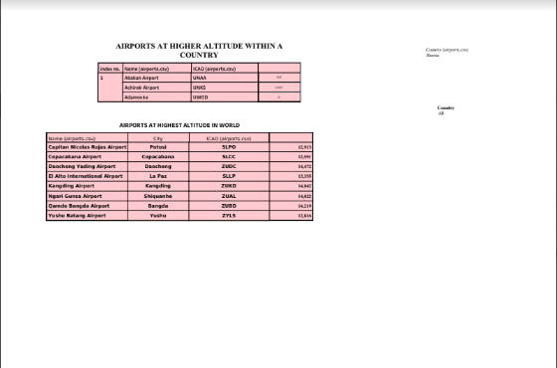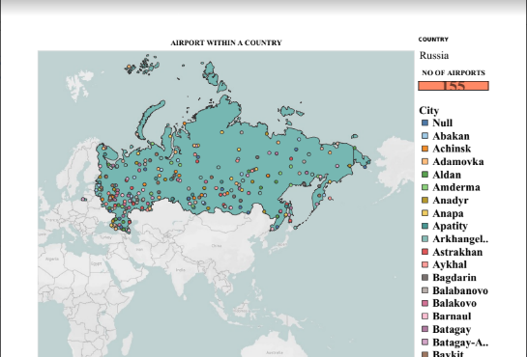 International Connectivity**: The dataset showcased the extensive international connectivity of many major airports. These airports serve as critical hubs for global travel, enhancing accessibility and convenience.**

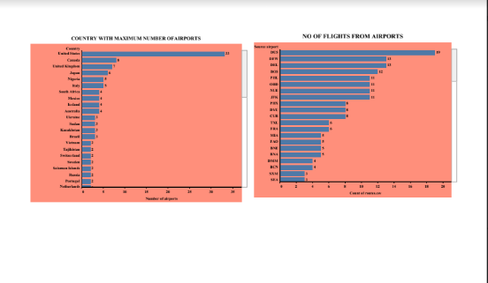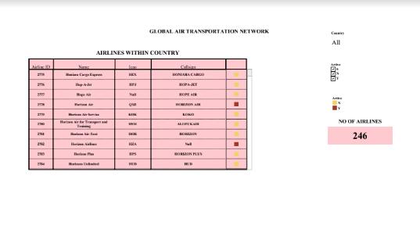

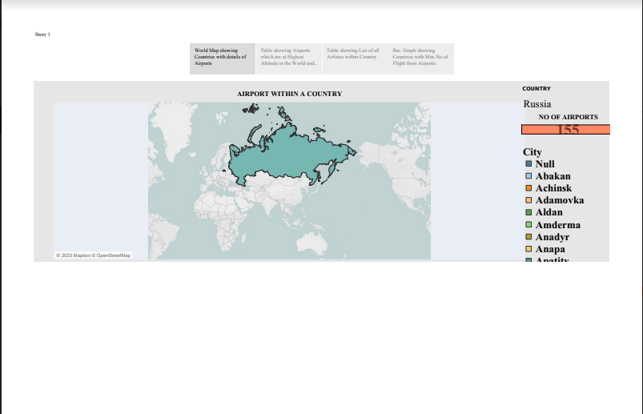

ADVANTAGE OF GLOBAL AIR TRANSPORTATION NETWORK

Global Coverage: The dataset encompasses information from airports and airlines worldwide, allowing for a holistic view of the global air transportation network. This global scope is advantageous for studying international travel and interconnectivity.

*Research Potential*: Researchers can use this dataset to analyze and understand global air transportation networks, which can be beneficial for various purposes, including studying travel patterns, identifying trends, and making informed decisions related to air travel and logistics

**DISADVANTAGE OF GLOBAL AIR TRANSPORTATION NETWORK**

Data Maintenance**: Airports, airlines, and routes are subject to changes, closures, and expansions. Keeping the dataset up-to-date is a challenging and resource-intensive task, and outdated information can limit its usefulness.**

Data Accuracy: The accuracy and reliability of the data may vary depending on the sources and methodologies used for compilation. Inaccurate or outdated information could lead to incorrect analyses and decisions.

APPLICATION:

Route Optimization for Airlines: Airlines can use the route optimization insights to enhance their flight planning, reduce operational costs, and minimize delays. This can lead to more efficient and cost-effective flight routes.

Investment Opportunities: Investors in the aviation sector can leverage your findings to identify promising regions, airports, and airlines for potential investments.

**Environmental Sustainability:** The project can contribute to the development of more eco-friendly aviation practices. Airlines and industry stakeholders can use the data to reduce carbon emissions, improve fuel efficiency, and support sustainable aviation initiatives.

CONCLUSION:

In conclusion, the analysis of the Global Air Transportation Network dataset with the utilization of Tableau has yielded valuable insights and data-driven recommendations for the aviation industry and its stakeholders. This project has served as an important resource for understanding the dynamics of the air transportation network on a global scale.

this project has provided a solid foundation for informed decision-making in the aviation industry. The data-driven insights and visualizations presented here aim to enhance route planning, boost operational efficiency, and contribute to a more environmentally sustainable aviation sector. Moreover, it offers a valuable resource for researchers, policymakers, and stakeholders looking to further analyze and refine the air transportation network.

future scope:

## **Predictive Analytics:** Implement predictive analytics to forecast potential flight delays, cancellations, and other operational issues. Predictive models can help airlines proactively address issues before they occur.

## **Mobile Application:** Create a mobile application that provides travelers with real-time flight information, including delays, gate changes, and baggage details, based on the data analysis from your project.

## **Education and Training:** Develop training materials and resources for aviation professionals and students to use your project's insights to enhance their knowledge of the industry.

APPENDIX:

Git Hup link: https://github.com/NM2023TMID10815/Global_Air-NM2023TMID10815.git